Technical Datasheet Input / Output Modules with Modbus RTU Protocol with RS485 Interface

The IO modules communicate via RS485. The port can drive distances up to max 700 meters without the use of any repeater (this feature however also depends on the signal strength of the Modbus Master Device).
The RS485 Digital IO module is sturdy, has low power usage and is easy to use.

8 DI + 8 AI – NTC Module: -
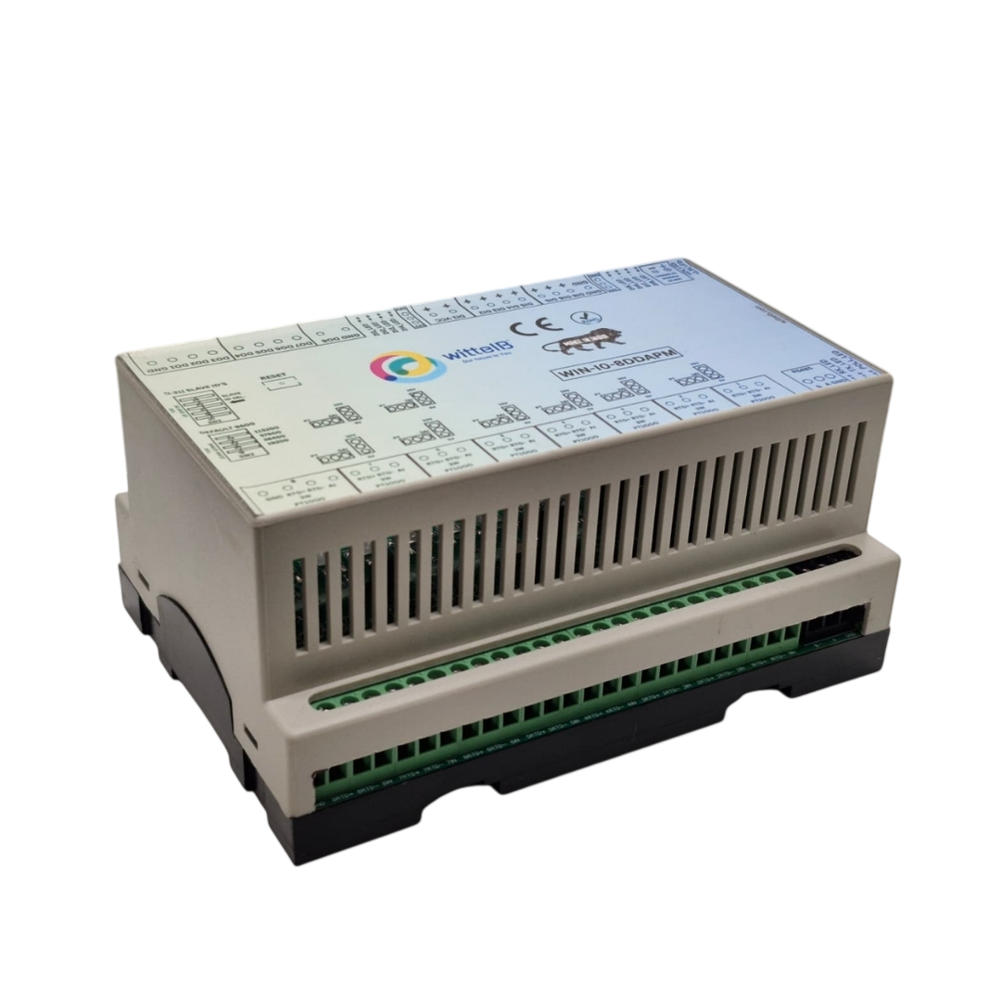
The IO modules are mounted on DIN rail mountable casing and with exposed connectors and LED indicators.

The design of the modules incorporates ‘resettable Fuses’ to safeguard against reverse polarity connection both for Power and Communication port.

Specifications
General –
I/O Connectors 12 Pin 5.08 mm pitch pluggable screw Terminal Block, 2 Pin 5.08 mm pitch pluggable screw terminals.
Dimensions 110 mm L x 110 mm B x 50 mm H
Power Input Power – 12 - 24 VDC or 24 V AC/DC
Typical – 12V DC @ 120mA
Operating Temperature 0 – 60° C (32 ~ 140°F)
Storage Temperature -20 - 70° C (-4 ~ 158°F)
Storage Humidity 5 ~ 95 % RH, non – Condensing
Certifications 

DI Inputs –
Channels 8
Sense Voltage 3.3 – 30 VDC
Sense Logic Logic ‘0’ = <1 VDC, Logic ‘1’ = >3.3 VDC
Isolation Optically isolated
Response Time 2 msec, Max 6 msec

AI Inputs –
Channels 8
Input Signal 4 – 20 mA / 0 – 10VDC / NTC Type 3 (jumper selectable)
Accuracy ± 2% Full scale
Input Resolution 10 bits / 12 bits (Optional)
Isolation Optically Isolated
External Loop Voltage + 12 VDC min
AI input impedance 120Ω

Additional Features: -
All inputs and communication ports isolated
Input power reverse polarity safety
ESD Safety IEC 61000-4-2, ± 30KV contact, ± 30KV air
EFT IEC 61000-4-4, 50A (5/50ms)
750V isolation.
CRC Error check.
No configuration needed on the IO board
Configuration Settings: -
Communication Speed 9600 – 115200.
Data Bits 8
Parity None
Stop bit 1
CRC Yes
Slave Id Soft Setting
Function code DI 0x02 Read discrete Input
DI Register Address 0,1,2,3,4,5,6,7,8.
Function Code AI 0x03 Read Holding Registers
AI Register Address 10 Bit - 1,2,3,4,5,6,7,8
Soft Serial Function Code 0x03 Read Holding Registers
Soft Serial Register Address 11,12,13,14,15,16,17,18.

ID | Function  Description | Register  Description | Modbus Function Code | Protocol | Data  Type
0 | DI 1(With & Without Potential) | 10001 | 0X02 | RS485 | 1 Bit Boolean
1 | DI 2(With & Without Potential) | 10002 | 0X02 | RS485 | 1 Bit Boolean
2 | DI 3(With & Without Potential) | 10003 | 0X02 | RS485 | 1 Bit Boolean
3 | DI 4(With & Without Potential) | 10004 | 0X02 | RS485 | 1 Bit Boolean
4 | DI 5(With & Without Potential) | 10005 | 0x02 | RS485 | 1 Bit Boolean
5 | DI 6(With & Without Potential) | 10006 | 0x02 | RS485 | 1 Bit Boolean
6 | DI 7(With & Without Potential) | 10007 | 0x02 | RS485 | 1 Bit Boolean
7 | DI 8(With & Without Potential) | 10008 | 0x02 | RS485 | 1 Bit Boolean
1 | AI 1 – 10 Bit | 40002 | 0X03 | RS485 | 16 Bit Unsigned int
2 | AI 2 – 10 Bit | 40003 | 0X03 | RS485 | 16 Bit Unsigned int
3 | AI 3 – 10 Bit | 40004 | 0X03 | RS485 | 16 Bit Unsigned int
4 | AI 4 – 10 Bit | 40005 | 0X03 | RS485 | 16 Bit Unsigned int
5 | AI 5 – 10 Bit | 40006 | 0x03 | RS485 | 16 Bit Unsigned int
6 | AI 6 – 10 Bit | 40007 | 0x03 | RS485 | 16 Bit Unsigned int
7 | AI 7 – 10 Bit | 40008 | 0x03 | RS485 | 16 Bit Unsigned int
8 | AI 8 – 10 Bit | 40009 | 0x03 | RS485 | 16 Bit Unsigned int
9 | Temperature1 | 40010 | 0x03 | RS485 | 16 Bit Unsigned int
10 | Temperature2 | 40011 | 0x03 | RS485 | 16 Bit Unsigned int
11 | Temperature3 | 40012 | 0x03 | RS485 | 16 Bit Unsigned int
12 | Temperature4 | 40013 | 0x03 | RS485 | 16 Bit Unsigned int
13 | Temperature5 | 40014 | 0x03 | RS485 | 16 Bit Unsigned int
14 | Temperature6 | 40015 | 0x03 | RS485 | 16 Bit Unsigned int
15 | Temperature7 | 40016 | 0x03 | RS485 | 16 Bit Unsigned int
16 | Temperature8 | 40017 | 0x03 | RS485 | 16 Bit Unsigned int
18 | Display Baud Rate (Default:960) | 40019 | 0x03 | RS485 | 16 Bit Unsigned int
19 | Enter New Baud Rate | 40020 | 0x03 | RS485 | 16 Bit Unsigned int
20 | Display Slave ID (Default:1) | 40021 | 0x03 | RS485 | 16 Bit Unsigned int
21 | Enter New Slave ID | 40022 | 0x03 | RS485 | 16 Bit Unsigned int
22 | Display Parity  (Default: None-3And for Odd-1,Even-2 | 40023 | 0x03 | RS485 | 16 Bit Unsigned int
23 | Enter New Parity | 40024 | 0x03 | RS485 | 16 Bit Unsigned int.
24 | Display Stop Bit  (start-2/stop bit-1) | 40025 | 0x03 | RS485 | 16 Bit Unsigned int.
25 | Enter New Start/ Stop Bit. | 40026 | 0x03 | RS485 | 16 Bit Unsigned int.

Note: -
- In register 40023- you will be able to see the current parity and you can change it to register 40024
- In register 40025- you will be able to see the current stop bit, and you can change it in register 40026
- If you want to enter the baud rate 9600/19200/38400/57600/115200etc.
Enter it as 960/1920/5760/11520etc.
- After that press the reset button or reboot the system.
BAUD RATE and SLAVE ID DESCRIPTION:
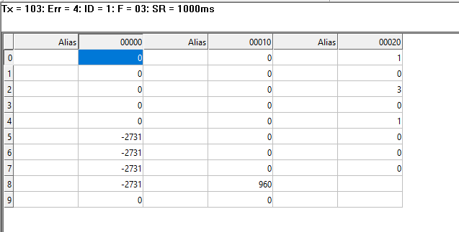
As you can see in the image above, the resistor 40019 – 960 represents the present bund rate
(9600) of the board and 40021– 1 represents the present slave id of the board.

To change the baud rate and slave id you have to enter a value on the 40020 resistor for the baud rate and 40022 for the slave id as shown in the image below.

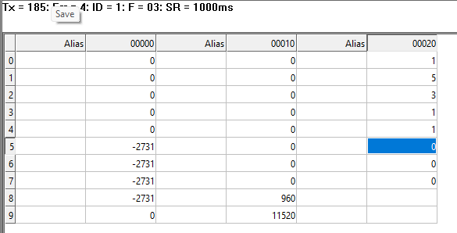
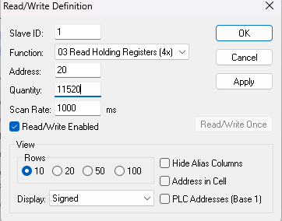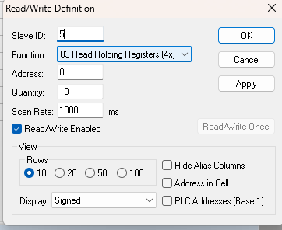

As you can see in the image above I set 115200 baud rate and slave ID 5.

Note:
1. If you want to enter the baud rate 9600/19200/38400/57600/115200etc.
Enter it like this 960/1920/5760/11520etc.
2. After that press the reset button or reboot the system.
3. Then you will get the present value of 11520 at 40019 baud rate(115200) and 5 at 40021 slave id.
4. You can Change Parity Bit , stop bit Of the device with same way.

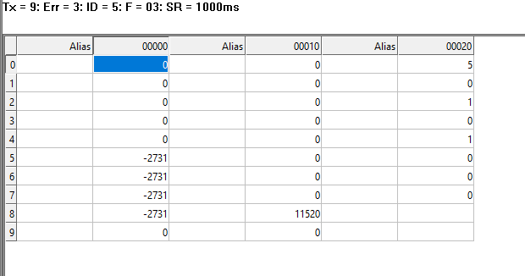

Note: -
For MODBUS communications, a shielded and twisted pair cable is used. One example of such cable is Belden 3105A.
Recommended Cable Electrical Characteristics: -
22 AWG Cable Shielded and twisted pair should be used.
Tinned Copper Recommended
Nominal Conductor DCR 14.7 ohm / 1000 ft
Nominal Capacitance 11 pf / feet (conductor to conductor)
High Frequency Non-Insertion Loss 0.5db / 100ft

DI

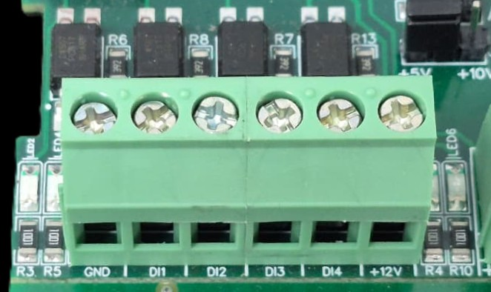
I/p device
I/p device
I/p device
I/p device

- Operation: The module provides four isolated input channels (DI1–DI4) for sensing external signals or dry contacts. These inputs are opto-isolated for circuit protection.
- Terminal Layout:
  - GND: Common Ground reference.
  - DI1 – DI4: Individual Digital Input channels.
  - +12V: Internal reference voltage for sourcing "Dry Contact" switches.
- Wiring Options:
  - Dry Contact: Connect a switch between the +12V terminal and any DI pin.
  - External Voltage: Connect the external signal to a DI pin and the external ground to the GND terminal.
- Voltage Rating: The input circuitry is rated for a maximum of 80VDC. Ensure external signals do not exceed this limit to prevent damage to the isolation ICs.

AI-NTC

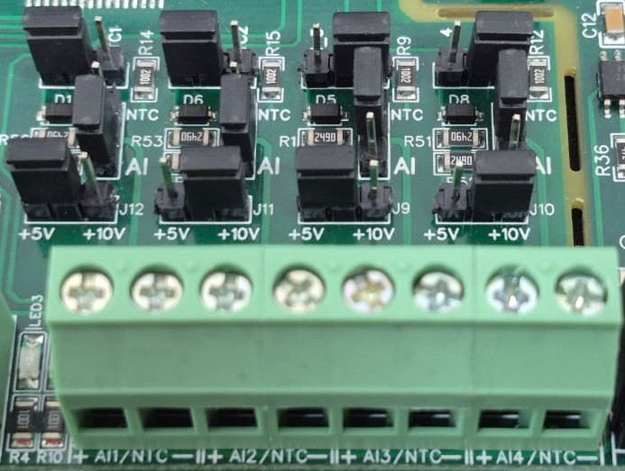
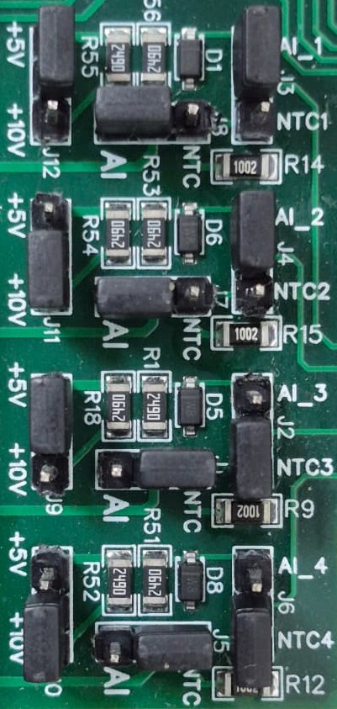
Sensor
Sensor
Sensor
Sensor

- Analog Input & NTC Operation: Each channel provides two terminals: + (Positive) and - (Negative/Common). These are used to interface with either standard external analog sensors or NTC thermistors.
- Channel Configuration (Visual Guide): Each of the four channels features two dedicated jumpers to independently select the operating mode (AI or NTC) and the reference voltage range (5V or 10V). Refer to the color-coded boxes in the board diagram to configure your desired scenario:
  - Red Box (AI Mode, 5V Range): Set the mode jumper to AI and the voltage jumper to +5V.
  - Green Box (AI Mode, 10V Range): Set the mode jumper to AI and the voltage jumper to +10V.
  - Blue Box (NTC Mode, 5V Range): Set the mode jumper to NTC and the voltage jumper to +5V.
  - Yellow Box (NTC Mode, 10V Range): Set the mode jumper to NTC and the voltage jumper to +10V.
- Sensor Wiring Connections:
  - The sensor or thermistor's positive signal wire should be connected to the + terminal of the desired channel (labelled AI1/NTC, AI2/NTC, etc.).
  - The sensor's common or ground wire should be connected to the corresponding - terminal.
- Crucial Setup Recommendation: Always ensure that both the mode jumper (NTC vs. AI) and the voltage jumper strictly match the hardware you are connecting. Incorrectly setting an NTC to an AI mode, or mismatching the voltage limits, will result in inaccurate temperature or signal readings.

BAUD RATE DESCRIPTION

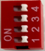
Default Setting
DIP switch

NOTE –
- By default, the Jumper setting on the board is 10 V and 10 Bit.

- By default, Baud rate DIP Switch 1 is set to ON, toggling it OFF and pressing reset button will bring the device to default RS485 Configuration i.e. Baud rate - 9600, Stop bit - 1, Parity - None, Data Bit - 8. Keep the indicated DIP switch to ON position for setting desired configuration.

1 2 3 4 5 6 7 8
DI +ve Pins
Common GNDD
Modbus RS485

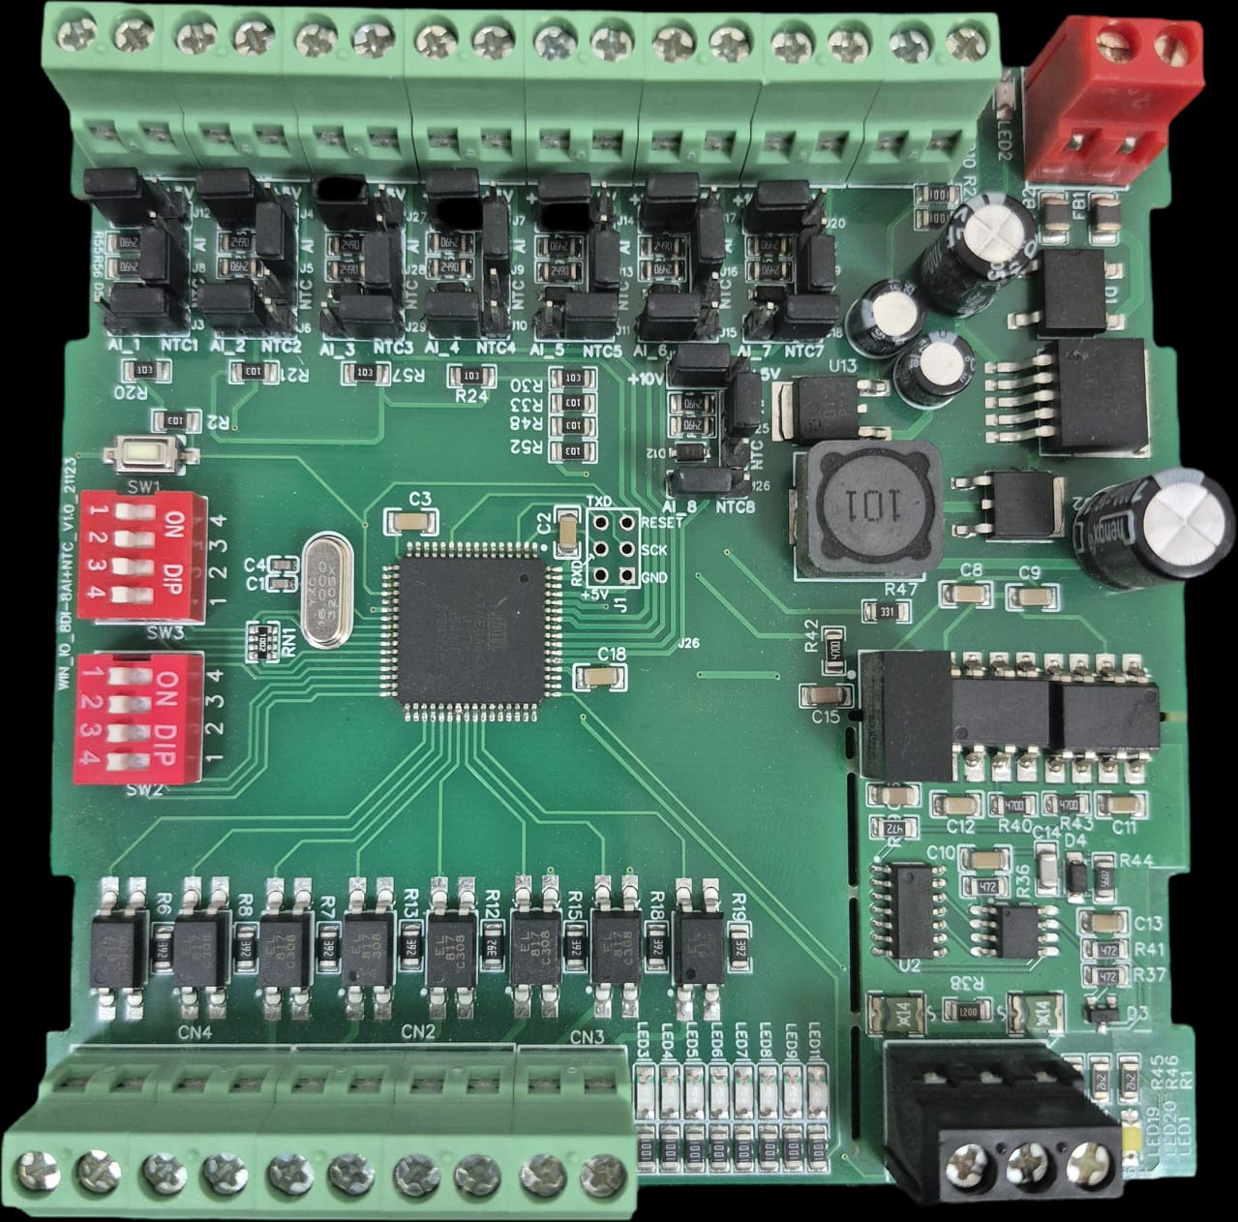
DIP
SWITCH
FOR
BAUDRATE
& SLAE ID
AI | NTC SELECT
5V / 10 V
Jumper
Input 12-24 VDC
AI8 AI7 AI6 AI5 AI4 AI3 AI2 AI1
Analog Input Pins
+12 V DI Ref
Reset Button

Contact us: -
Augmatic Technologies Pvt. Ltd.,
Plot no 6, Shah Industrial Estate II,
Kotambi, Vadodara – 391510.
Email – Sales@wittelb.com
Support: support@wittelb.raiseaticket.com / +91 94038 92805

